Handout 3: Images

Image 1: Drawing of soldiers building earthworks at Cold Harbor. (Forbes, Edwin. “The Battle of Cold Harbor, Throwing Up Breastworks.” Drawing. June 1864. Library of Congress.)
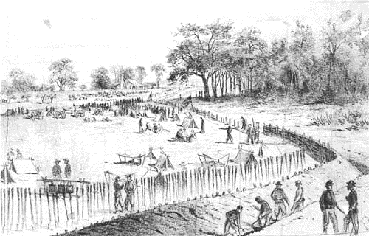

Image 2: Photograph of Federal troops occupying a line of earthworks on the North Anna River in Virginia. (O’Sullivan, Timothy H. “North Anna River, VA. Federal Troops Occupying Line of Breastworks on the North Bank.” Photograph. 25 May 1864. Library of Congress.)
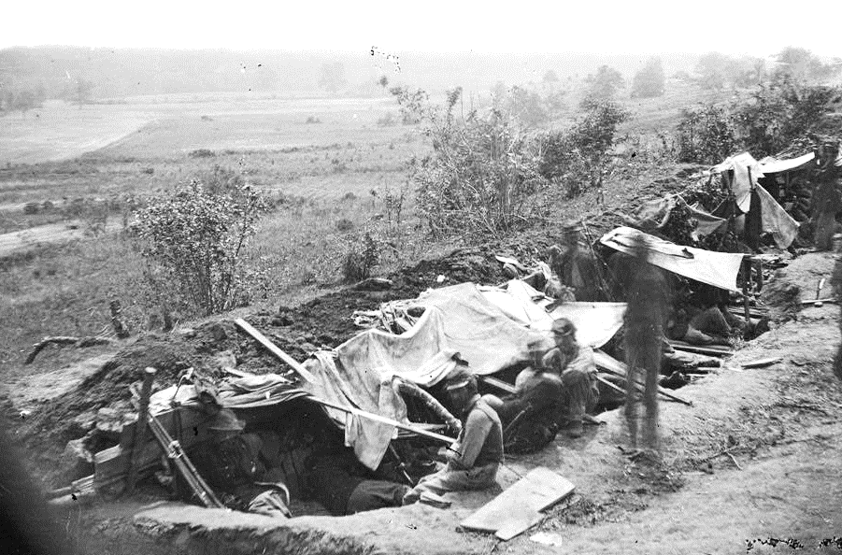

Image 3: Drawing of soldiers constructing earthworks. (Waud, Alfred R. “On Hancocks front.” June 3, 1864. Library of Congress.)
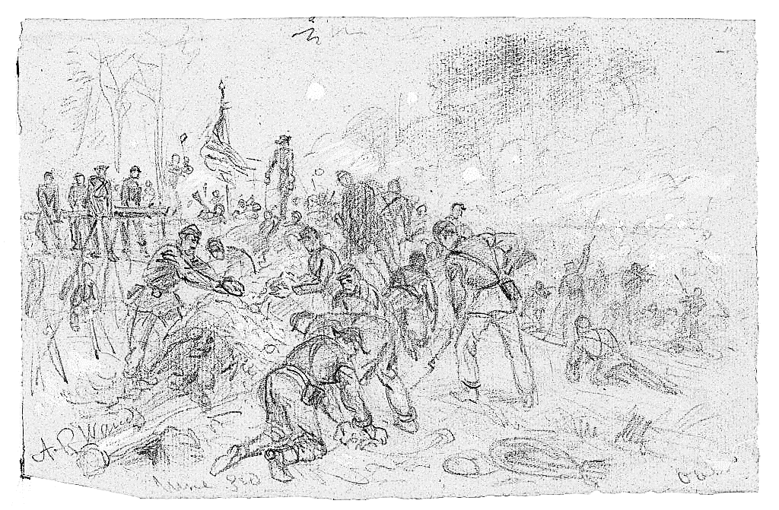
Image 4: Soldiers on the battlefield had to adapt to their circumstances. The object shown in these two photographs was once a tin canteen carried by a soldier at Cold Harbor. However, it was intentionally cut to be used as a shovel for digging earthworks. (National Park Service.)
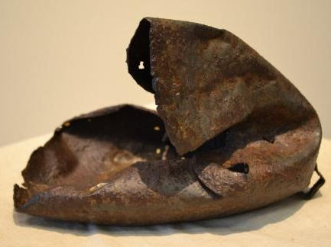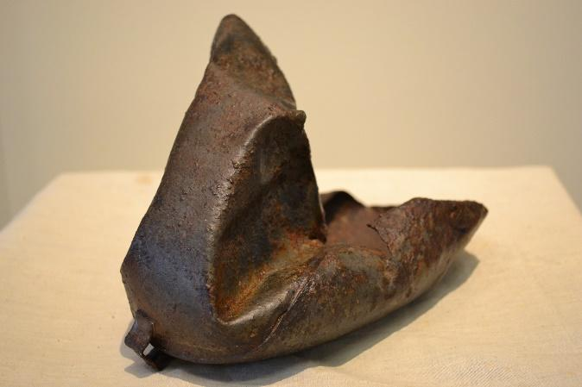
Image 5: Cold Harbor Battlefield today. Under the 1979 Archeological Resources Protection Act, it is illegal to have metal detectors on or to remove any artifacts from federal land. (National Park Service.)

